Supplementary Information
for Size-Dependent Reliability of Empirical Potentials for Global Optimization of Pt-Cu Bimetallic Clusters
Xiaomin Wu ª, Yousi Lin *ª, Miao He ^{b}, Yuheng Chen ^{c} and Hua Shi ª
- School of Opto-Electronic and Communication Engineering, Xiamen University of
Technology, Xiamen, China. E-mail: wuxiaomin@xmut.edu.cn, linyousi@xmut.edu.cn, shihua@xmut.edu.cn
- School of Electrical Engineering and Automation, Xiamen University of Technology, Xiamen, China. E-mail: hemiao@xmut.edu.cn
- Pen-Tung Sah Institute of Micro-Nano Science and Technology, Xiamen University, Xiamen, China. E-mail: hyc2537@163.com

Table of Content
S1. Empirical-Potential Parameter Sets 1
S2. DFT Candidate Coverage Across Composition 2
S3. Structural Retention after DFT Relaxation 3
S4. Additional Structure-Origin Evidence for the N = 38 FS Basin 4
S5. Reference Motif / Additional Comparison Material 6

S1. Empirical-Potential Parameter Sets
The empirical-potential global searches in this work were carried out with the parameter sets summarized in Tables S1-S3. These tables are provided so that the comparison reported in the main text can be reproduced independently and so that the role of parameter choice can be examined separately from the role of the functional form.

Table S1. Gupta-potential parameters used in the global search.
Pair | A (eV) | ξ (eV) | p | q | r₀ (Å)
Pt-Pt | 2.7747 | 0.2975 | 2.695 | 10.612 | 4.004
Cu-Cu | 2.556 | 0.0894 | 1.224 | 10.96 | 2.278
Pt-Cu | 2.665 | 0.1631 | 1.8162 | 10.7860 | 3.141
The values are taken from Ref. [21] of the main text.
Table S2. Sutton-Chen parameters used in the global search.
Pair | ξ (eV) | a (Å) | C | m | n
Pt-Pt | 0.0097894 | 71.336 | 3.9163 | 11 | 7
Cu-Cu | 0.0057921 | 84.843 | 3.6030 | 10 | 5
Pt-Cu | 0.0075300 | 78.0895 | 3.75965 | 10.5 | 6
The values are taken from Ref. [23] of the main text.
Table S3. Finnis-Sinclair parameters used in the global search.
Pair | cutoff | c0 | c1 | c2 | d | c | beta
Pt-Pt | 3.80 | 1.24 | -0.36 | -0.04 | 4.00 | 1.83 | 1.8
Cu-Cu | 3.50 | 1.24 | -0.36 | -0.04 | 3.70 | 1.83 | 1.8
Pt-Cu | 3.65 | 1.24 | -0.36 | -0.04 | 3.85 | 1.83 | 1.8
The values are taken from Ref. [24] of the main text.
The parameter sets in Tables S1-S3 were applied without further refitting throughout the present benchmark. We emphasize that the assessment in the main text characterizes the behavior of each potential under the specific parameter set listed here.

S2. DFT Candidate Coverage Across Composition
To test whether the empirical-potential candidates map to the same part of the DFT landscape across composition, Table S4 compares Cu-rich, near-equiatomic, and Pt-rich cases rather than relying on a single composition. The key N = 23 result is that the DFT-lowest candidate changes with composition, indicating that different empirical potentials can locate DFT-competitive basins in different parts of Pt-Cu composition space.
The composition-resolved DFT energies in Figure S1 show two complementary trends. At N = 13, the three potentials are essentially degenerate at the off-equiatomic compositions Pt₃Cu₁₀ and Pt₁₀Cu₃ in line with the strong icosahedral motif consensus reported in the main text; only at the near-equiatomic point Pt₆Cu₇ does the FS candidate become clearly distinguishable, lying 0.665 eV above the near-degenerate Gupta and SC candidates. At N = 23, by contrast, the DFT-lowest empirical potential rotates with composition: FS is lowest in the Cu-rich case (Pt₅Cu₁₈), SC is lowest at the near-equiatomic composition (Pt₁₁Cu₁₂), and Gupta is lowest in the Pt-rich case (Pt₁₈Cu₅). This composition-dependent rotation, summarized in Table S4, is the direct DFT-level evidence supporting the size- and composition-dependent reliability picture emphasized in the main text.

Table S4. Composition-dependent DFT-lowest empirical-potential candidate for the tested N = 23 cases.
Composition regime | Tested case | DFT-lowest candidate
Cu-rich | N = 23, Pt5Cu18 | FS
Near-equiatomic | N = 23, Pt11Cu12 | SC
Pt-rich | N = 23, Pt18Cu5 | Gupta

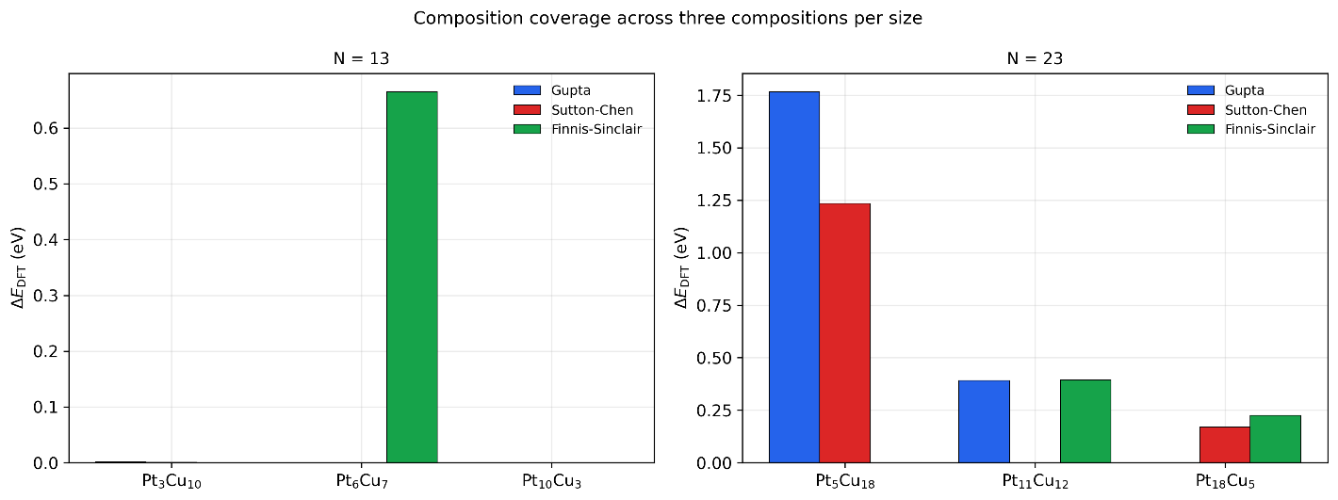
Figure S1. Composition-coverage comparison showing that the DFT-lowest empirical-potential candidate changes across the tested Cu-rich, near-equiatomic, and Pt-rich N = 23 cases.

S3. Structural Retention after DFT Relaxation
For the cluster sizes where full DFT ionic relaxation was carried out (N = 13 and N = 23), the structural response of each empirical-potential candidate is summarized in Table S5. The root-mean-square displacement (RMSD) between the EP-optimized geometry and the corresponding relaxed DFT geometry quantifies how strongly each candidate is reorganized when first-principles forces take over; the maximum residual force at the end of the relaxation verifies that all reported geometries are converged with respect to the force criterion stated in the main-text Methods section.

Table S5. EP-to-DFT structural retention for the tested Pt-Cu candidates at N = 13 and N = 23.
N | Composition | Potential | RMSD (Å) | Max residual force (eV/Å)
13 | Pt₆Cu₇ | Gupta | 0.107 | 0.029
13 | Pt₆Cu₇ | SC | 0.065 | 0.033
13 | Pt₆Cu₇ | FS | 0.124 | 0.025
13 | Pt₃Cu₁₀ | Gupta | 0.098 | 0.031
13 | Pt₃Cu₁₀ | SC | 0.080 | 0.030
13 | Pt₃Cu₁₀ | FS | 0.129 | 0.030
13 | Pt₁₀Cu₃ | Gupta | 0.236 | 0.025
13 | Pt₁₀Cu₃ | SC | 0.249 | 0.026
13 | Pt₁₀Cu₃ | FS | 0.334 | 0.026
23 | Pt₁₁Cu₁₂ | Gupta | 0.357 | 0.028
23 | Pt₁₁Cu₁₂ | SC | 0.097 | 0.024
23 | Pt₁₁Cu₁₂ | FS | 0.499 | 0.021
23 | Pt₅Cu₁₈ | Gupta | 0.333 | 0.014
23 | Pt₅Cu₁₈ | SC | 0.087 | 0.026
23 | Pt₅Cu₁₈ | FS | 0.158 | 0.029
23 | Pt₁₈Cu₅ | Gupta | 0.215 | 0.027
23 | Pt₁₈Cu₅ | SC | 0.197 | 0.035
23 | Pt₁₈Cu₅ | FS | 0.679 | 0.027
The values in Table S5 support the qualitative trends described in the main-text RMSD discussion: SC-derived candidates exhibit the smallest structural rearrangement upon DFT relaxation across the tested cases, FS-derived candidates undergo the largest reorganization (most clearly at N = 23), and Gupta-derived candidates lie in between. The simultaneous convergence of the maximum residual force across all reported cases confirms that the RMSD differences reflect genuine structural retention rather than incomplete relaxation.

S4. Additional Structure-Origin Evidence for the N = 38 FS Basin
As shown in Table S6, the compact FS candidate at N = 38 is distinguished by a pronounced feature near 143° in the bonded-dihedral distribution. This feature is treated here as a structural signature of the FS-specific local packing pattern rather than, by itself, as evidence of energetic preference on the DFT landscape.

Table S6. Supplementary summary of the N = 38 bonded-dihedral enrichment near 143°.
Metric | FS candidate |  | Gupta reference
Dihedrals within 143° ± 5° |  | 731 / 9869 (7.4%) | 9 / 7248 (0.1%)
Dominant central-bond character | Pt-Pt 60.6%, Pt-Cu 36.4%, Cu-Cu 3.0% |  | No comparable enrichment at 143°
The contrast between Figures S2 and S3 makes the FS-specific nature of the 143° dihedral feature explicit. The FS distribution is continuous and broadly populated, with the 143° band carrying about 7% of the total dihedral count; the Gupta distribution is concentrated at a few discrete angles, with essentially no occupation of the 143° band. Combined with the central-bond breakdown in Table S5 (Pt-Pt 60.6%, Pt-Cu 36.4%, Cu-Cu 3.0% within the 143° window of the FS candidate), this confirms that the 143° feature is a fingerprint of an FS-specific compact, Pt-rich local packing pattern rather than a shared structural property at N = 38.
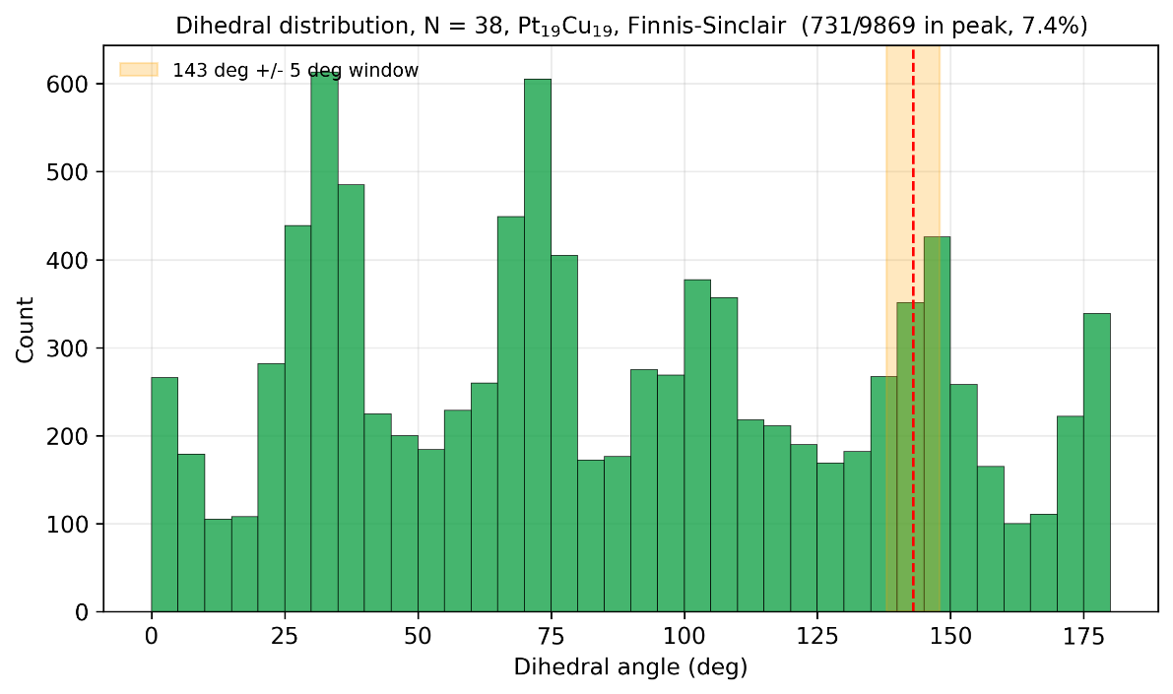
Figure S2. Dedicated bonded-dihedral analysis for the N = 38 FS candidate at Pt19Cu19, highlighting the supplementary 143° structural signature.
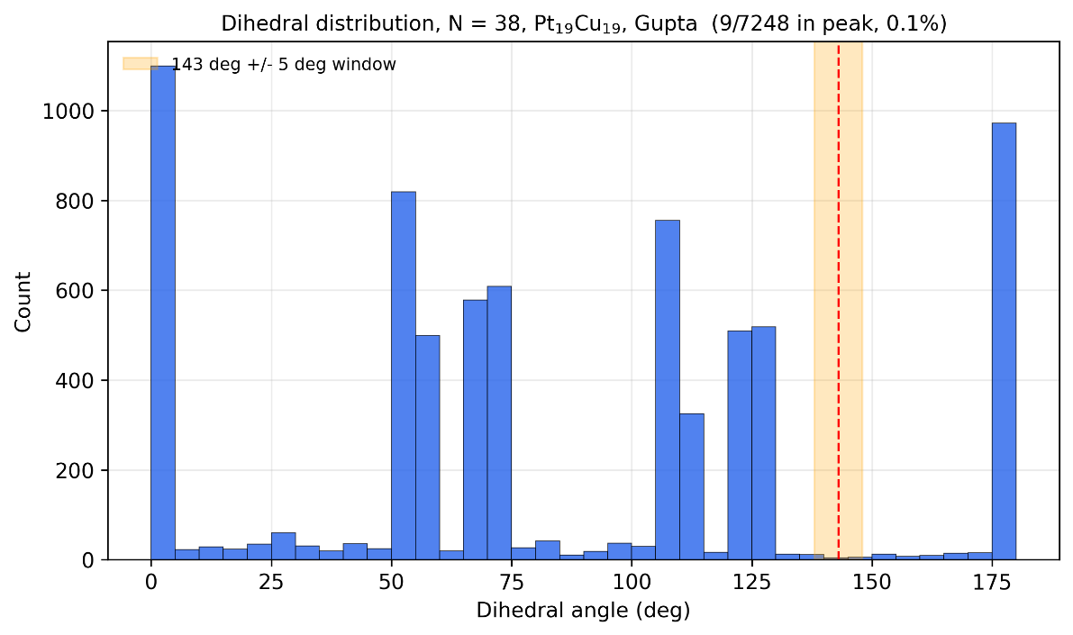
Figure S3. Gupta reference bonded-dihedral analysis for N = 38, shown for comparison with the FS-specific 143° enrichment.

S5. Reference Motif / Additional Comparison Material
Figure S4 visualizes the single-point DFT screening that underpins the DFT ranking discussed in the main text. At each size, the EP-optimized global minimum at the common near-equiatomic composition is re-evaluated by DFT, and the three candidates are reported relative to the lowest-energy structure. At N = 13, the Gupta and SC candidates are degenerate within numerical precision and the FS candidate lies 0.665 eV higher. At N = 23, the SC candidate is lowest, while the Gupta and FS candidates are higher by 0.392 and 0.393 eV, respectively. At N = 38, the SC candidate remains lowest, the Gupta candidate is 1.038 eV higher, and the FS compact 143°-signature motif is 2.895 eV higher. The ordering changes with cluster size and is not predictable from the EP-internal energetic preferences alone, supporting the main-text conclusion that descriptor-level rankings and DFT energetic competitiveness do not collapse into a single ranking.

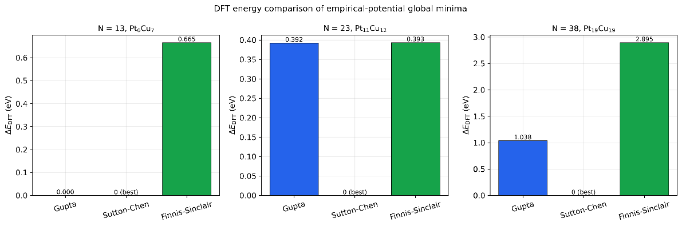
Figure S4. DFT energy comparison of the EP-optimized global minimum structures at the common near-equiatomic compositions, Pt₆Cu₇ for N = 13, Pt₁₁Cu₁₂ for N = 23, and Pt₁₉Cu₁₉ for N = 38. For each size, ΔE_DFT is referenced to the lowest-energy candidate among the three potentials (labeled "0 (best)").

